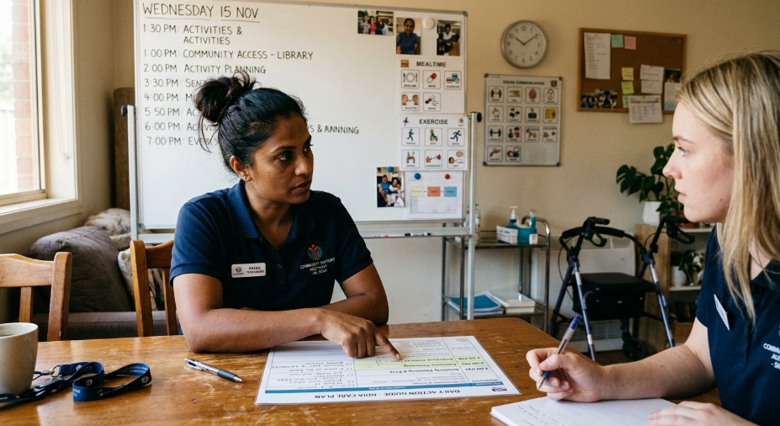
Learner #7: Priya Sharma

About Me: | Priya is a 34-year-old Team Leader with Community Care NSW, based in Parramatta, where she runs Shared Independent Living (SIL) housing for clients with high-intensity care needs. She has seven years of practical disability sector experience and four years in her current leadership role. Priya lives in Parramatta with her partner, and her work pattern is largely predictable Monday to Friday with occasional weekend on-call duty.
Professional and Learning Experience: | Priya holds three units toward CHC40312 Certificate IV in Disability (CHCICS402B, CHCCS411C, and CHCAD401D, attained 2013) and HLTAID011 Provide First Aid (current to 2027). She has completed the NDIS Worker Orientation Module and holds internal signoffs for medication administration, PEG feeding, and complex manual handling. Her practical experience is substantial: NCI and PBS implementation, complex medication rounds, restrictive practice management, NDIS audit preparation (zero non-conformances across two recent audits), advocacy at NDIS planning meetings, and primary on-the-job mentoring for all new hires in her cluster.  Priya has independently developed a “Daily Action Guide” system for her houses, which has been adopted as a regional template, and recently led the successful rollout of the CareLog digital incident reporting system across three pilot houses (notification compliance lifted from 82 percent to 99 percent). She is enrolled in TAE40122 with the support of her employer.
Career/Training Goals: | Priya's stated goal is to move into a formal trainer role within her organisation's RTO branch, delivering the Certificate IV in Disability. She has been earmarked by her Area Manager as the next Lead Trainer for the medication and first aid modules and has been encouraged to shadow current trainers across these units to observe formal adult learning principles in action. Longer term, she is interested in delivering NDIS-aligned skill sets and may pursue further qualifications in advanced PBS or disability practice leadership.
Working Style and Preferences: | Priya is exceptionally systematic. Her documentation is described in her appraisal as “highly detailed,” her clinical compliance record is “flawless,” and her project management of the CareLog rollout was delivered with the kind of structured, methodical rigour that is rare at her career stage. She produces clear written guides ahead of any session, prefers to follow a defined sequence, and tends to over-prepare rather than under-prepare. She is at her best in one-on-one coaching, in writing, and in small, structured groups with a clear agenda.  Her appraisal specifically identifies that her staff meetings are excellent for “information-sharing” but that she needs to develop skills in managing group dynamics in less-structured classroom or workshop settings, where the conversation is more fluid. Priya has mentioned that she finds noisy, fast-paced group environments tiring and that she will sometimes need a quiet space and a few minutes of solo time to reset between sessions. She is direct in her communication and tends to take instructions and feedback literally, which can occasionally read as blunt to people who are not familiar with her style; she has shared that she sometimes finds the social side of large workplace gatherings draining even when she enjoys the substantive content.  Priya is highly proficient with digital tools (CareLog, the NDIS portal, Canva Pro, Microsoft Publisher, Word, and Excel), has her own laptop, and reliable NBN internet.
Additional Information: | Priya is a keen long-distance runner and runs the same 7-kilometre route each morning before work; she has mentioned that the routine is genuinely important to her ability to manage a demanding day. She received an adult diagnosis of autism spectrum condition in her late twenties, which she has shared with her current employer for workplace adjustment purposes (primarily around quiet space access and clear written agendas) but does not bring up unprompted. Her preferred way of learning new content is to receive structured written materials, work through them solo, and then bring specific questions to a follow-up session.

